Question 1.

Case:
A movie studio produces films and the studio would like to track information related to the cast and crew so that the credit sequence for each film will be easy to generate. Each film is based on a script that is created by at least one writer and the writers are ranked on the script (for instance it is typical for the main writer to be listed first, followed by a co-writer, etc., so a rank of 1 for the main writer). A film has a cast of actors and a crew of professional crew members and each has a part or a job on the film.

Task:
Create an ERD for the above case.
Question 2.
Convert ERD to Relational Schema

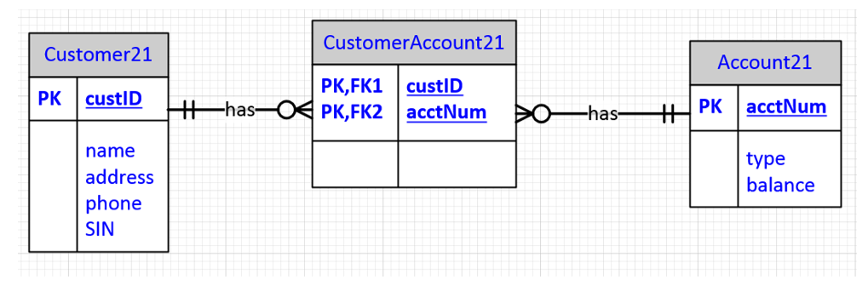
Question 3.
For each:
1) Identify the keys (primary)
2) Identify functional dependencies that violate 2NF
3) Identify the functional dependencies that violate 3NF
4) Decompose into a set of relations that satisfies 3NF

- Invoice (InvNo, InvDate, CustNo, CustName, ItemNo, ItemName, ItemPrice, Qty)
The functional dependencies are:
    - InvNo InvDate, CustNo
    - CustNo CustName
    - ItemNo ItemName, ItemPrice
    - InvNo, ItemNo Qty

- Consider a system that tracks projects and the employees assigned to them, and the charges to have these employees on the job:
Project (ProjNum, ProjName, EmpNum, EmpName, JobClass, ChgHour, Hours)
The functional dependencies:
    - ProjNum ProjName
    - EmpNum EmpName, JobClass
    - JobClass ChgHour
    - ProjNum, EmpNum Hours
Question 4.
1.Create Table Publisher
Create a table named Publisher with the following:
- publisherID → 4-digit integer (Primary Key).
- publisherName → character type up to 20 characters – must have a value.
- publisherCity → character type up to 15 characters – optional.
- yearFounded → 4-digit integer – must be greater than 1800.

2.Sample Data

Publisher ID | PublisherName | PublisherCity | yearFounded
1001 | Penguin Books | London | 1935
1002 | HarperCollins | San Jose | 1986
1004 | Bloomsbury | London | 1989
1007 | Random House | Barcelona | 1990
1003 | Harryporter | New York | 1994

3.Add a new column country that can store up to 20 characters.
4. Modify the publisherName column to allow up to 30 characters.
5. Drop the existing CHECK constraint on yearFounded.
6. Display all the columns from the Publisher table.
7. Display only the publisherName and publisherCity of all publishers in London.
8. Display the publisherName and yearFounded of publishers founded after 1980.
9. Update the publisherCity to 'Toronto' where publisherID is 1002.
10. Delete the publisher record where the publisherName is 'Harryporter'.

